Tax Bill activity
Original version of the House Bill -
http://taxmama.com/tax-quips/summary-tax-cut-and-jobs-act-2017/
https://www.wsj.com/livecoverage/tax-bill-2017
https://www.marketwatch.com/story/here-are-the-winners-and-losers-of-the-senate-tax-plan-2017-11-13
https://www.forbes.com/sites/kellyphillipserb/2017/11/16/senate-markup-would-make-individual-tax-cuts-temporary-corporate-tax-cuts-permanent
Obamacare Individual Mandate
- Under the original House and Senate proposals, the mandate would still be in play.
- Under the proposal as outlined in the Chairman's Mark, the individual mandate penalty would be eliminated beginning in 2019.
Above The Line Deductions
Currently, you can claim certain above-the-line expenses (meaning that you can claim them even if you do not itemize).
- Under both proposals, most above-the-line deductions would be eliminated, including those for student loan interest, moving expenses and out of pocket expenses for teachers.
- Under the proposal as outlined in the Chairman's Mark, the above-the-line expense limit for teachers would stay in effect but the limit would be increased to $500 (it's currently $250).

Ian had a question
Do I have reasonable cause for the IRS to reconsider a disallowance of a claim for refund for tax year 2013 because of missing the filing deadline?

Here is what happened:

I amended a 2013 tax return to claim additional federal & state refunds for business write-offs that a client had been unaware of at the time he self-prepared his original return. The client signed his 2013 amended return on April 12, 2017. The amended return was postmarked to the IRS on April 18, 2017.

The IRS has disallowed the claim for the refund because " ... [the return] was filed more than 3 years after the tax return due date ... The last day to file a claim for tax year 2013 was April 15, 2017. We can't allow your claim because the postmark isn't on or before the deadline."

Bottom line:

I was confused as to the correct due date to file the amended 2013 return. Within recent memory, the IRS due date of April 15 has been pushed out an extra day because of Emancipation Day observed in Washington D.C. (plus the 15th fell on the weekend this year.) So, being a rush - I told the client the filing deadline for his 2013 return was April 18 this year, and that is the day the return was mailed.

Do you think that "excuse" - of being confused because of Emancipation Day etc. will fly with the IRS? Is there a more compelling way for me to communicate that mix-up about the due dates, so that IRS will reconsider and release the refund to my client for 2013?

Answer? No – actually, research:
https://www.timeanddate.com/calendar/monthly.html?year=2013&country=1&month=4
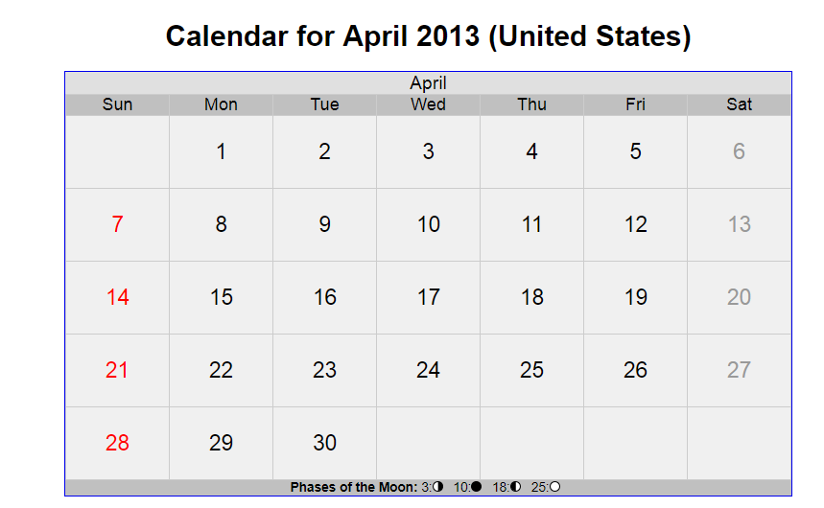
2014 filing deadline https://www.timeanddate.com/calendar/monthly.html?year=2014&country=1&month=4
2013 filing deadline - https://www.irs.gov/newsroom/irs-kicks-off-2013-tax-season was April 15th.
If the taxpayers were living in Washington State, they had until October 15th to file https://www.irs.gov/newsroom/irs-gives-tax-relief-to-washington-state-mudslide-and-flooding-victims
https://www.irs.gov/irm/part25/irm_25-006-001r

https://www.irs.gov/irm/part25/irm_25-006-001r#idm140534001710336
25.6.1.10.2.5.1 (10-17-2016)

Statute Year Amended Returns Requesting a Credit, Tax Decrease, or No Tax Change
4. If an untimely claim for refund is referred to the Statute function for review and research indicates an unreversed TC 420 or 424, forward the claim to the Examination function.

https://www.irs.gov/irm/part25/irm_25-006-001r#idm140534001681616
25.6.1.10.2.5.3 (09-20-2016)

Notification to Taxpayer Upon Disallowance of a Claim
- Do not allow a claim for refund if the claim for refund is received after RSED has expired, even if the claim contains an issue that the taxpayer has a right to appeal. Issue a certified Letter 105C, Claim Disallowed, to the taxpayer. Input a TC 290.00 amount, using Blocking Series (BS) 98 or 99, as appropriate.
- Taxpayer’s Period of Limitations for Filing a Refund Suit. The two-year period of limitations for filing a refund suit under IRC Section 6532(a) does not begin until the Service sends a notice of claim disallowance unless the taxpayer executes and files a Form 2297, Waiver of Statutory Notification of Claim Disallowance, which would start the two-year period.

Note:
To start the IRC Section 6532(a) period, a notice of claim disallowance must unequivocally state that the claim was disallowed. See Letter 105C Claim Disallowed, or Letter 106C Claim Partially Disallowed. A math error notice is not a final notice of claim disallowance.

Note:
IRM 25.6.1.6.2., Identifying Undeliverable Mail, if the 105C letter is undeliverable, for more information.
- A notice of a claim disallowance is not mandatory. The Service may make a business decision not to send a notice of claim disallowance in every situation even though the taxpayer’s period for filing a refund suit remains open; e.g., if the Service denies an Earned Income Tax Credit (EITC) and issues a notice of deficiency, a taxpayer may file a Tax Court petition and the Court will have jurisdiction to redetermine the EITC. The Service may decide not to issue a notice of claim disallowance in this situation.
- A disallowance letter may be sent when the claim is untimely, as well as when the Service disagrees with the taxpayer’s position on a substantive matter; however, a "no consideration" letter is not a disallowance letter. A disallowance letter shows that the taxpayer satisfied the requirement in IRC Section 7422 that the taxpayer must file a claim with the Service before filing suit in a district court or the Court of Federal Claims.

26 U.S. Code § 6511 - Limitations on credit or refund
https://www.law.cornell.edu/uscode/text/26/6511

26 U.S. Code § 7422 - Civil actions for refund
https://www.law.cornell.edu/uscode/text/26/7422
26 U.S. Code § 6532 - Periods of limitation on suits
https://www.law.cornell.edu/uscode/text/26/6532

Tax Court – searched “Sec 6511, refund” – one case
Galen K. and Katherine J. Heichel
https://ustaxcourt.gov/UstcInOp/OpinionViewer.aspx?ID=8321
Interesting argument, not relevant, and taxpayers lost anyway.
Searched “untimely refund” – one case
Mary Ellen & Thomas Ford Kalil
https://ustaxcourt.gov/UstcInOp/OpinionViewer.aspx?ID=10544
Not relevant – a collection case with missing records – interesting.

